How to Colaboratory Documents

Colaboratory (colab) documents are like a Google Doc, but they allow you to combine text and working python code in a single document. It is like a living textbook that you can make a copy of and then play with the python code to better understand how it works. You can also use these documents to explain things like data analysis that may use python code to demonstrate something. They are very cool. [There is a language for formatting the documents](https://towardsdatascience.com/cheat-sheet-for-google-colab-63853778c093).

To add colab documents to your Google Drive hit the new button in your drive and go to “more” and the “connect more apps”.

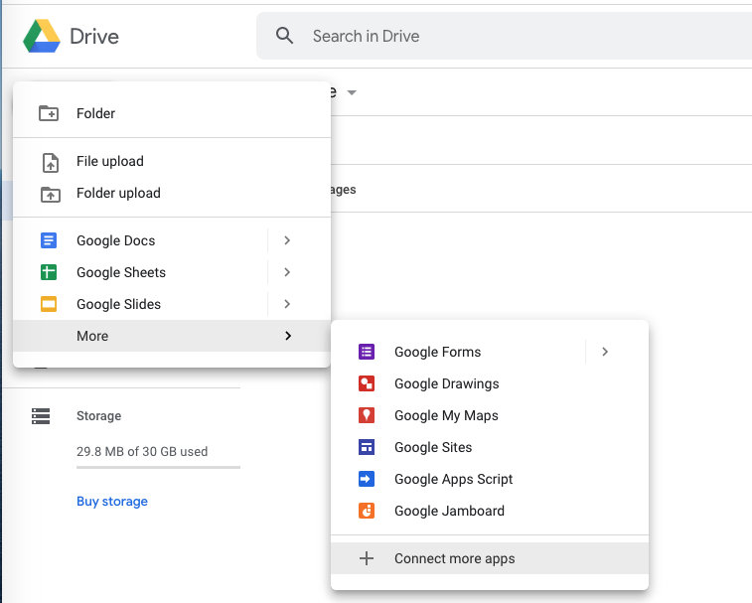

In the pop-up window search for “Colaboratory”.

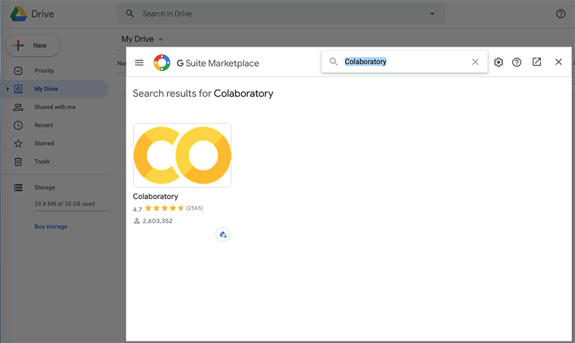

Select the Colaboratory add-on and click the install button.

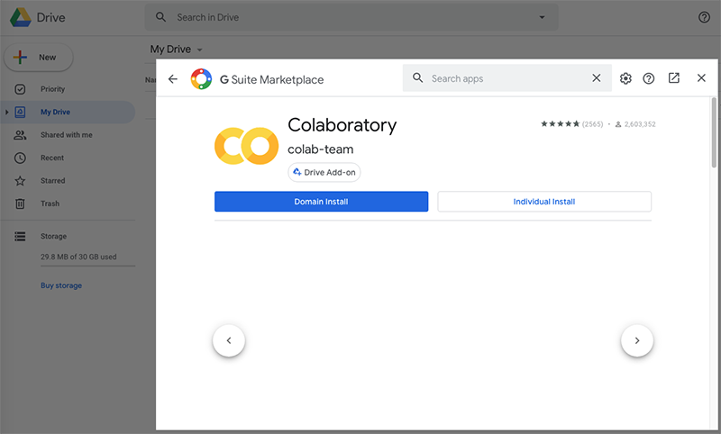

Once the add-on is installed you can create colab notebooks just like you would create a Google doc by hitting the “New” button.

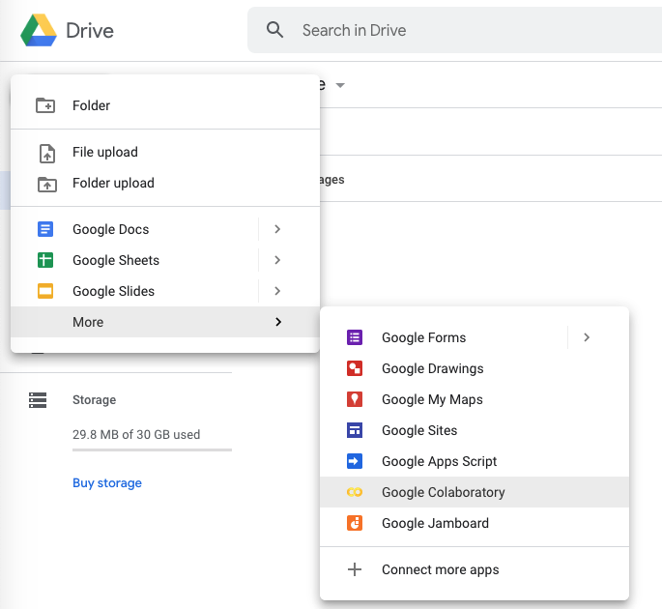

Depending on your account you may get a new folder in your drive called Colab Notebooks. If this is the case anytime you make a copy of a colab notebook that document will be placed in that new folder. The file does not have to stay in that folder; you can place it anywhere you want in your drive. Hope this helps, have fun playing with colab notebooks.

